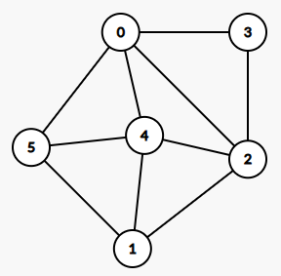

0, 5, 4, 1, 2, 3, 0